Efficient Fine-Tuning & Preference Alignment in Multimodal AI

Goal of this Module
The goal here is to show how to adapt massive pretrained multimodal models (like LLaVA, GPT-4o, or custom VLMs) efficiently and reliably for specific domains, such as styling Odisha sarees for your fashion app — without retraining billions of parameters. You'll learn:
- LoRA: the go-to method for cheap, fast, parameter-efficient fine-tuning
- Preference tuning techniques (RLHF vs. DPO) to reduce hallucinations and make outputs truthful, helpful, and grounded in the actual image
- Practical steps, math intuition, costs, and results for real-world use cases like e-commerce fashion advice This knowledge lets you turn a general VLM into a specialized, trustworthy expert (e.g., Odia/English saree stylist) in days instead of weeks or months.
Imagine your huge multimodal model (like LLaVA or a custom VLM) is a giant marble statue — beautiful, but you want to tweak just the smile a little for your Odisha saree customers. Do you carve the entire 7-billion-parameter statue again? No way.
LoRA is like sticking a tiny, flexible Velcro patch exactly where you need it. You freeze the original statue (the pretrained weights) and only train the small patch. At the end, you glue the patch on permanently — zero extra cost during real use.

How LoRA Actually Works (Step-by-Step Intuition + Math)
Every layer in your model has a big weight matrix W (size d × d, where d is usually 4096 or 8192).
Instead of changing W directly, LoRA adds a tiny update ΔW:
$h=Wx+ΔW⋅x$

But ΔW is not full size, it’s decomposed into two much smaller matrices:
$ΔW=B⋅A$

- A is d × r (r = rank, usually 8 or 16 — super small!)
- B is r × d
- So total trainable parameters = 2 × d × r → often just 0.1%–1% of the original model!
During training:
- W stays completely frozen (snowflake icon in diagrams).
- Only A and B get updated.
- After training, you can permanently merge:
$Wnew=W+BA$
and throw away A and B.
In the fashion app:

You have LLaVA-1.5-7B (vision encoder + LLaMA backbone).
You collect 4,000 high-quality pairs: customer saree photo + accurate styling advice + fabric details in Odia/English.
Instead of spending ₹5 lakh on full fine-tuning (and 4 days on 8 GPUs), you apply LoRA only on the LLM layers and projector (rank=16).
Result:
- Trains on a single 24GB GPU in one evening.
- Model now says things like “This cotton saree has beautiful ikat motifs — pair it with silver jhumkas for a festive look” instead of hallucinating silk.
- File size increase: just 50–80 MB extra adapter file (you can switch adapters for different customers — wedding vs office wear).
Code Implementation Example (Simple LoRA layer in PyTorch:- conceptual):
import torch
import torch.nn as nn

class LoRALayer(nn.Module):
def __init__(self, in_features, out_features, rank=16, alpha=32):
super().__init__()
self.lora_A = nn.Parameter(torch.zeros(in_features, rank))
self.lora_B = nn.Parameter(torch.zeros(rank, out_features))
self.scaling = alpha / rank
# Original weight is frozen elsewhere

def forward(self, x):
delta = (x @ self.lora_A) @ self.lora_B * self.scaling
return delta # Add to original linear output

# Usage: replace linear layers with original + LoRA addition

Preference Tuning
After basic fine-tuning (or even after LoRA), models can still confidently lie about images (“heavy zari work” when the photo is plain border).
Preference tuning fixes exactly that by letting humans (or AI) rank answers and teaching the model:
“Helpful + grounded in the actual photo” > “Helpful but hallucinated” > “Rude or vague”
Two main ways people do this today:

A. RLHF (Reinforcement Learning from Human Feedback) — The Original (Used in ChatGPT)
This was the method behind InstructGPT and early GPT-4. It’s powerful but complex.

Step-by-step flow:
- Supervised Fine-Tuning (SFT): Train on good demonstration examples (“Here’s how to describe a saree photo”).
- Train a Reward Model: Humans compare pairs of responses for the same image+question:
  - Response A: “This is pure silk with zari” (but image shows cotton)
  - Response B: “This is soft cotton with minimal border” → Human picks B as better. Reward model learns to give higher score to grounded answers.
- Reinforcement Learning (PPO): Use the reward model as a teacher. The main model generates answers, gets a score, and is updated to chase higher scores (while a KL penalty stops it from going too crazy).
Here’s the classic RLHF pipeline diagram:

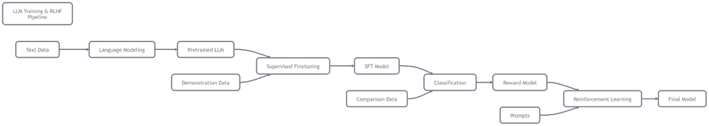

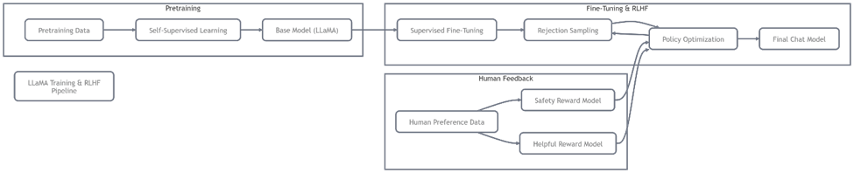

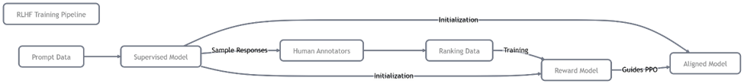

B. DPO (Direct Preference Optimization) — The 2024–2026 Winner (Much Simpler!)
DPO threw away the complicated RL part and found a beautiful mathematical shortcut.

How DPO works (super simple):
You only need preference pairs (same prompt/image, two answers):
- y_winner (grounded, truthful)
- y_loser (hallucinated)
DPO directly optimizes the model with this loss:
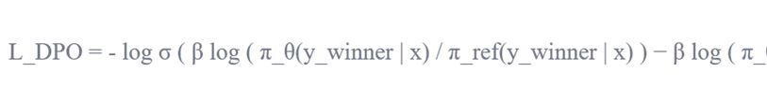
“Push the probability of the winner up and the loser down, relative to a frozen reference model — no reward model needed.”
That’s it. One single training step. No RL, no separate reward model.
Look how clean the comparison is:
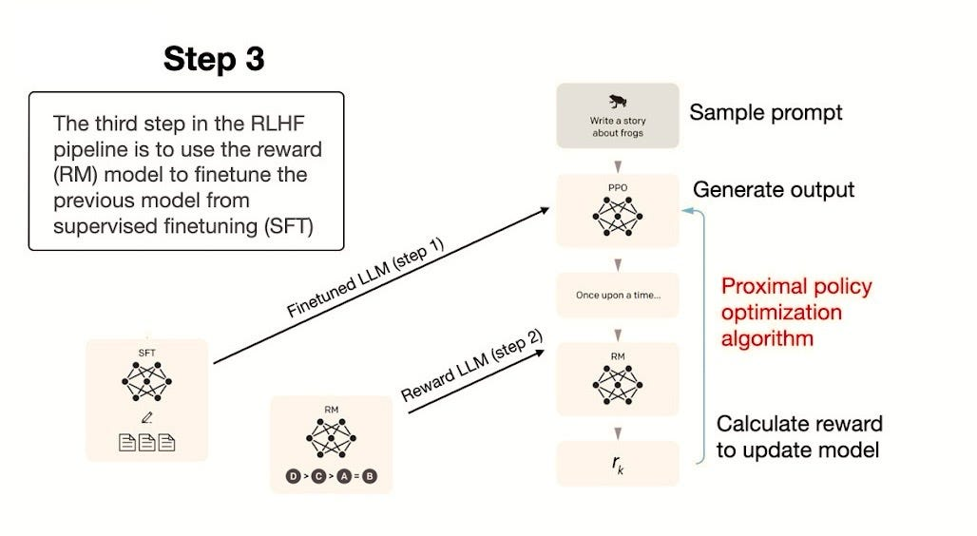

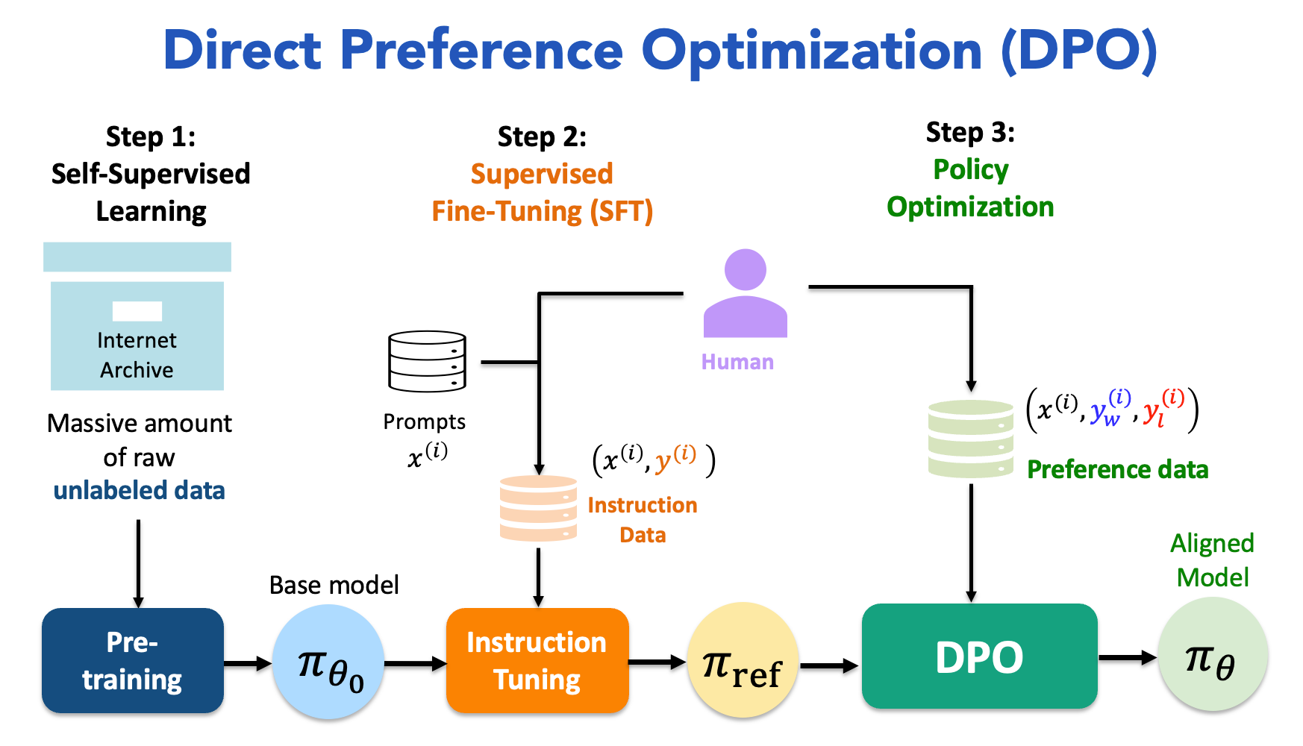

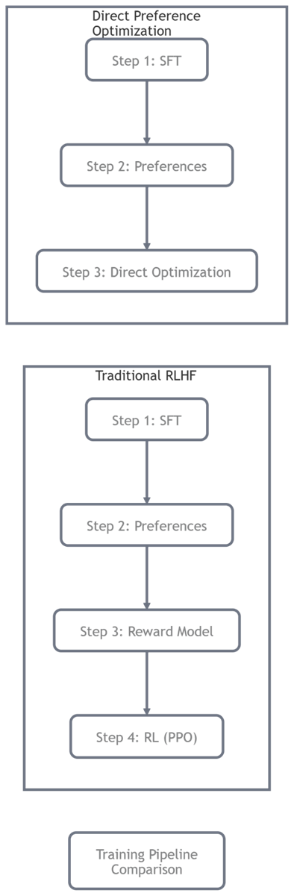

When to Use Which?
- Use LoRA + DPO (recommended for 95% of cases): Fast, stable, cheap. Perfect for your fashion app — reduces visual hallucinations dramatically in 1–2 days of training.
- Use full RLHF only when: You need ultra-precise personality (customer support tone), strong safety guarantees, or you already have a huge reward-model team.
In your app:
After LoRA fine-tuning, you collect 2,000 preference pairs where humans mark “this description actually matches the photo” vs “this one is guessing”.
DPO then teaches the model: “Never say ‘silk’ unless the image texture clearly shows sheen and drape.” Result? Customers trust the styling advice, returns drop, and your app feels magically accurate.

Code Implementation Example (DPO loss snippet – conceptual):

# Simplified DPO loss intuition

def dpo_loss(policy_logps_w, policy_logps_l, ref_logps_w, ref_logps_l, beta=0.1):

# Push winner prob up, loser down relative to reference

diff_w = policy_logps_w - ref_logps_w

diff_l = policy_logps_l - ref_logps_l

loss = -torch.log(torch.sigmoid(beta * (diff_w - diff_l)))

return loss.mean()

Conclusion & Key Takeaways

Efficient fine-tuning and preference alignment turn general multimodal giants into domain experts, accurate, fast, and affordable.

Key Takeaways

LoRA lets you adapt billion-parameter VLMs with <1% trainable parameters, train on one GPU, merge for free inference.

DPO is the modern, simple winner over RLHF: direct preference optimization eliminates reward models and RL complexity while achieving excellent alignment.

Combine LoRA + DPO for domain-specific multimodal apps (e.g., Odisha saree styling): low cost, low hallucination, high trust.

In practice: collect targeted data (photos + correct advice / preferences), apply LoRA to LLM/projector, then DPO on ranked pairs → dramatic quality jump.

Future edge: multiple LoRA adapters (switch for wedding/office/casual) + DPO-tuned grounding = personalized, reliable AI stylist.

